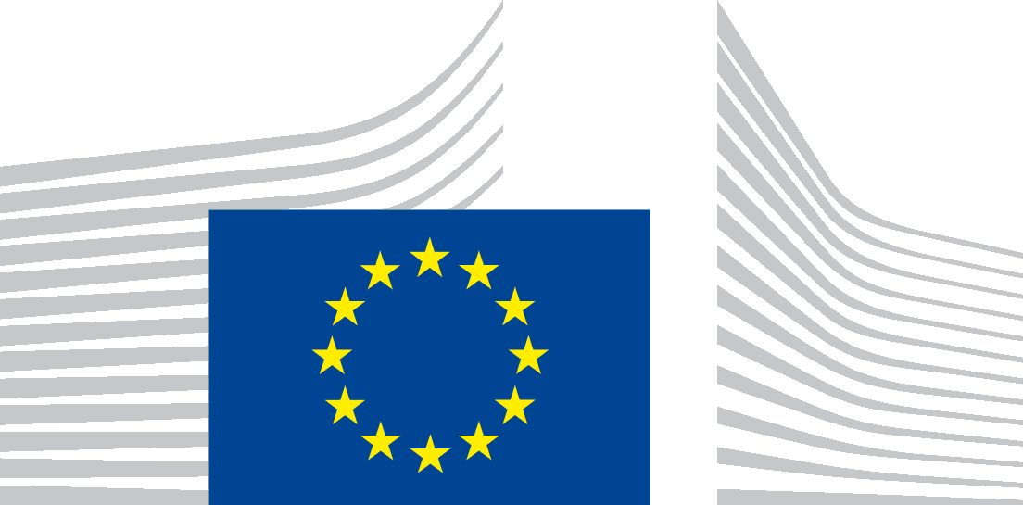
Local publication for call for proposals
Rule of law- Support to Civil Society capacities – Republic of Serbia
CIVIL SOCIETY FACILITY AND MEDIA PROGRAMME 2019
EuropeAid/168079/DD/ACT/RS
The Delegation of the European Union to the Republic of Serbia is seeking proposals for increasing capacities of the Serbian CSOs to address reform processes and EU integration process in the field of law in the Republic of Serbia with financial assistance from the Civil Society Facility Programme.
The full guidelines for applicants are available for consultation on the following internet sites:
https://webgate.ec.europa.eu/europeaid/online-services/index.cfm?do=publi.welcome&nbPubliList=15&orderby=upd&orderbyad=Desc&searchtype=RS&aofr=168079
The deadline for submission of proposals is 15/05/2020, at 15:00 hrs CET
An information session on this call for proposals will be held on 31/03/2020 at 12:00 CET, in EU Info centre, Kralja Milana 7, Belgrade, which will be simultaneously available for live streaming at EU Info points in Nis and Novi Sad.

